**Computer Programming 1  
Essential Standard 7.02 Apply One-Dimensional Arrays**

In all programs, put your name, the assignment name and the date in comments at the top.

**Programming Exercises**

1. Create a project called rates. The purpose of this program is to create an array that will hold 5 double values. Use the following numbers to initialize (populate) the array: 2.3, 2.2, 2.0, 2.1, 2.4. Display the lowest rate in a label.  
   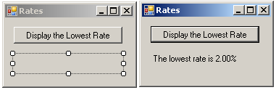
2. Create a project called Birthdays. The purpose of this program is to have parallel arrays that will hold four person’s names in the first array, then the four person’s birthdates in the second array. Populate the array’s using a For loop and InputBoxes, then display all of the information in a ListBox.  
   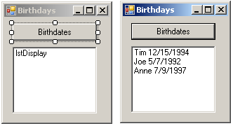
3. Create a project called gpaArray. The purpose of this program will be to add 5 GPA values to a ListBox. Use a Sub to add the values to the array and another Sub to display the values. Display the GPA values in ascending order.  
   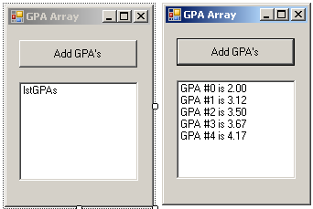
   1. Create your form as shown.
   2. Create a sub called addGpa that has reference variable for the array parameter.  
      Private Sub addGPA (ByRef dblGpaArr As Double)
   3. Create a sub called displayGpa that has a value parameter for the array parameter.  
      Private Sub displayGpa (ByVal dblGpaArr As Double)
   4. Create a button click that creates an array to hold the double values and calls both subs.
4. Create a project called DrawCards. The purpose of this program is to simulate drawing a card from a partial deck of cards where you only have the 2 through 10 cards. To do this, you will randomly generate a number from 2 to 10 the number of times entered in the TextBox. Use an array to hold the count.  
   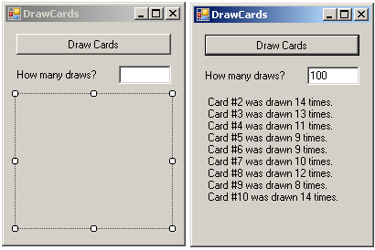
   1. Create your form as shown.
   2. Create the following subs and add appropriate code.  
      Private Sub drawCards(ByRef intCardCount() As Integer, ByVal intTimes As Integer)  
      Private Sub showCards(ByVal intCardCount() As Integer)
   3. Your button click should get the input and call the subs.
5. Create a project called RandomNums. The purpose of this program is to generate 10 random integer numbers between 1 and 100 and store them in an array. Create subs to 1) generate the random numbers, 2) display the number and 3) find the low and high numbers. When the Generate Numbers button is clicked, the numbers should be generated and displayed in the ListBox. When the Show High button is clicked the high number should be displayed and when the Show Low button is clicked the low number should be displayed.  
   